Building Contractor Commercial Registrations
Grandfathering arrangements

Background
The Northern Territory Government is introducing registration requirements for building contractors undertaking Class 1b and 3-9 building work. This new registration is part of a reform program to ensure confidence in the construction industry by ensuring commercial builders have the appropriate qualifications and experience.
Building contractors who undertake most work on Class 1b and 3–9 buildings will need to be registered.
An exception to the need for registration will be for renovations or alterations to an existing building, if there is no increase in floor area or height, provided there is no alteration or removal of any structural support elements and there is no change in use that impacts on compliance with the National Construction Code or changes the building classification.
To support experienced and skilled building practitioners to continue to work as normal, a grandfathering initiative will be applied to bring current Northern Territory builders into the registration scheme.

What is grandfathering?
Grandfathering allows builders in the Northern Territory to obtain a building contractor commercial registration based on their commercial building work experience without needing to meet qualification requirements.
A builder wanting to grandfather into the commercial registration scheme must apply for grandfathering from 15 April 2024 to 14 April 2025 (12 month transition period). After this period full registration requirements will apply to anyone wanting to become registered as a commercial building contractor.

Who can apply for the grandfathering?
Any Northern Territory builder who can demonstrate at least 3 years’ recent experience building Class 1b, Class 3 -9 buildings in the Northern Territory can apply under grandfathering for either of the following types of registration:
- up to 3 storeys for Building Contractor Commercial (Restricted); or
- greater than 3 storeys for Building Contractor Commercial (Unrestricted).
You will need to provide a net assets certificate, certified by a registered accountant, that you have Net Tangible Assets of $50,000 or more. You will also need to provide other information to make sure you are a fit and proper person to be registered, such as references and financial history.

I only do commercial fit-out building works, do I need to be registered?
You do not need to be a registered commercial builder to do renovations or alterations to commercial buildings if there is no increase in floor area or height, no structural elements have been altered and there is no change in use that impacts on compliance with the National Construction Code or changes the building classification.

Can I hold both a commercial and residential registration?
Yes. If you are a registered building contractor with experience doing commercial building work, you will be able to apply for registration as a commercial builder. You will need to demonstrate 3 years’ experience doing commercial building work in the Northern Territory. You will only be charged a registration fee for your initial registration (i.e. residential) and you will not be charged for a second registration (i.e. commercial).
The 12 month grandfathering initiative, from 15 April 2024 to 14 April 2025 is only applicable to commercial registration applications.

Who will review grandfathering applications?
The Building Practitioners Board reviews all building contractor registration applications and this will also include applications for grandfathering, from 15 April 2024 to 14 April 2025..
Where a reference is required from the Building Practitioners Board, it should be given by a building practitioner, preferably registered in the Northern Territory. The reference should give details about your involvement and responsibility in projects relevant to the category of registration you have applied for.

Where do I lodge my application for grandfathering?
Application forms and referee statement forms are available from 15 April 2024 at: https://bpb.nt.gov.au/application-forms. Completed applications can be lodged in person, email or via post at a Territory Business Centre operated by the Department of Industry, Tourism and Trade.
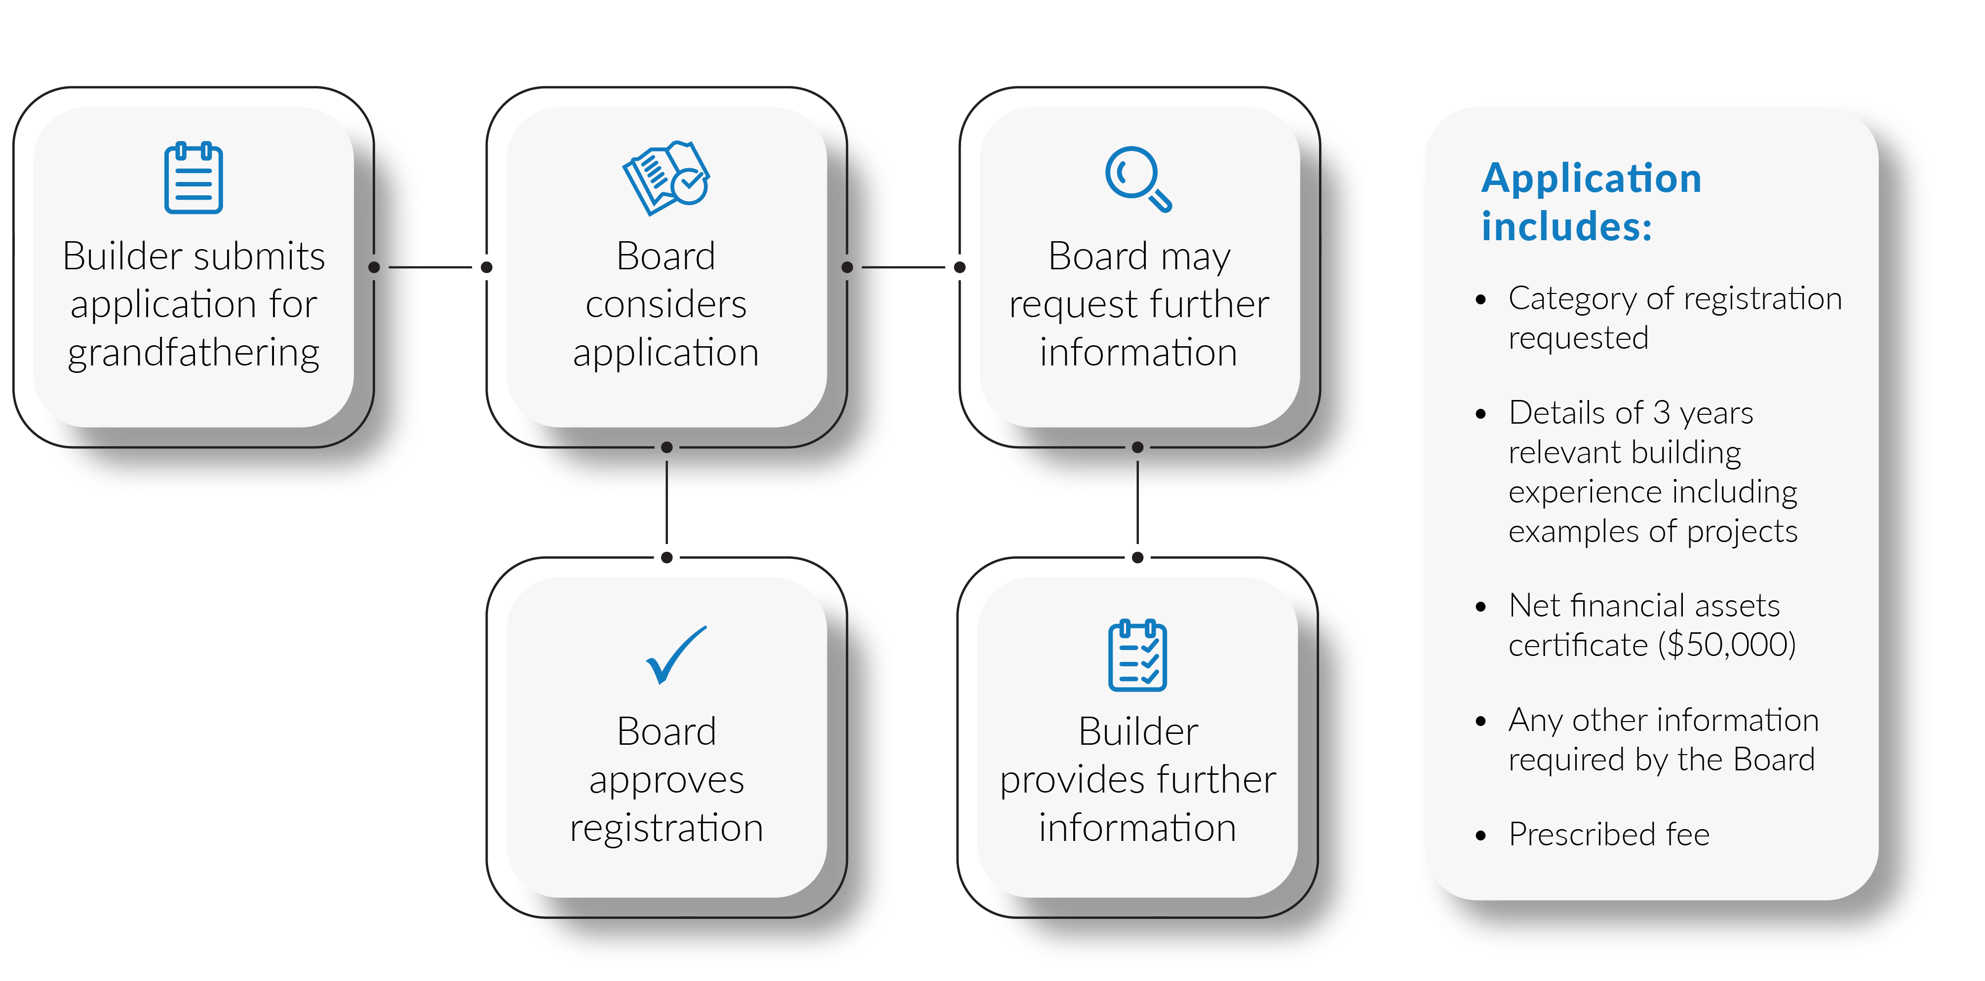The flowchart below outlines the process for grandfathering applications.

